

Name: Tehreem Mirza
Registration number : FA22-BSE-088
Class: BSE8B
Lab Task: 02, 03
Submitted to: Sir Ibrahim

- Task 02
Create Account on any two Cloud platforms ( AWS, Azure, GCP, DigitalOcean, Vultr, Hetzner, Huwavei, Oracle cloud, Alibaba,etc).

AWS Account creation :

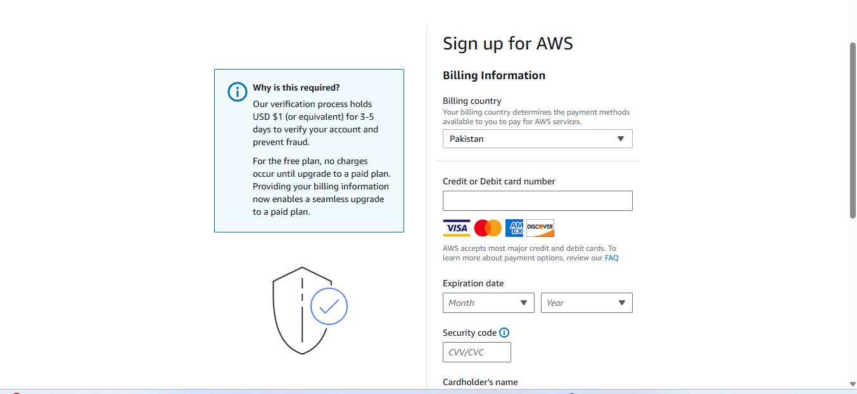

- Account has been created:
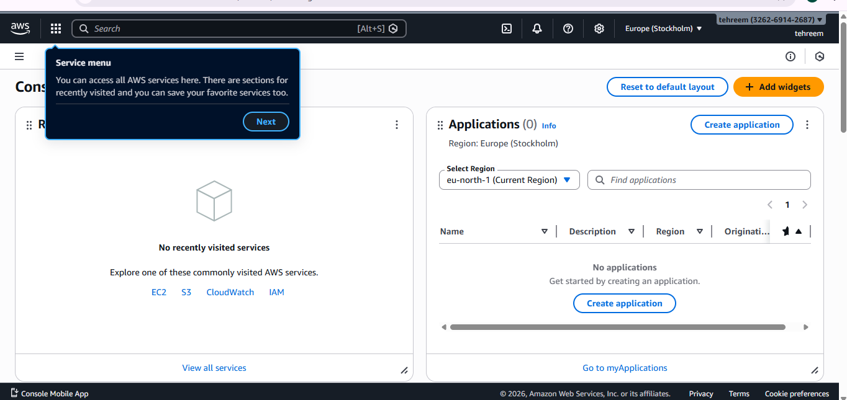

- Account cretaion on azure :
Signup with edu email your uni one .

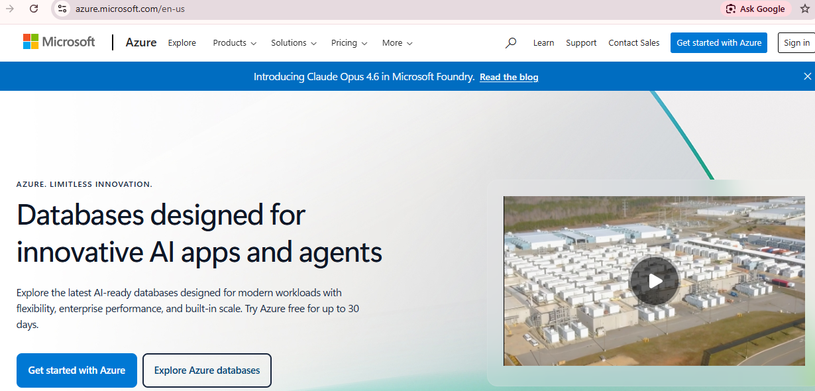

Select first option.
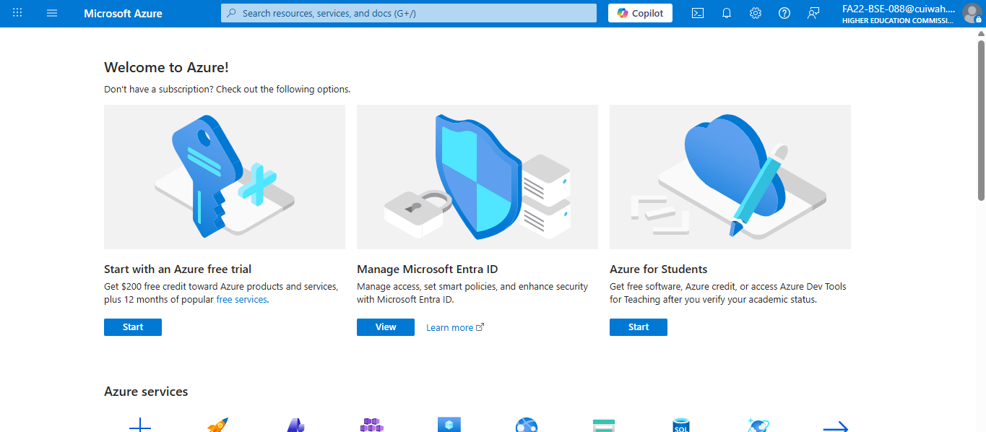

Then on signup and add details:

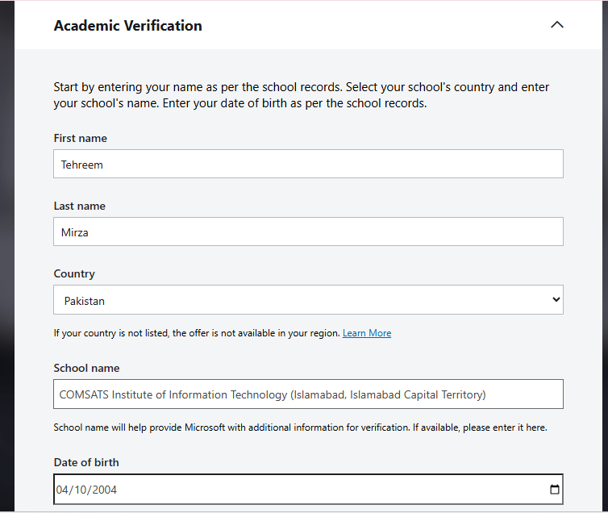

- Task 03:
Create Virtual machine on any Cloud platform
as well and access it via SSH client . e.g. Putty software or ssh command on cmd to access server. or EC2 instance on AWS.

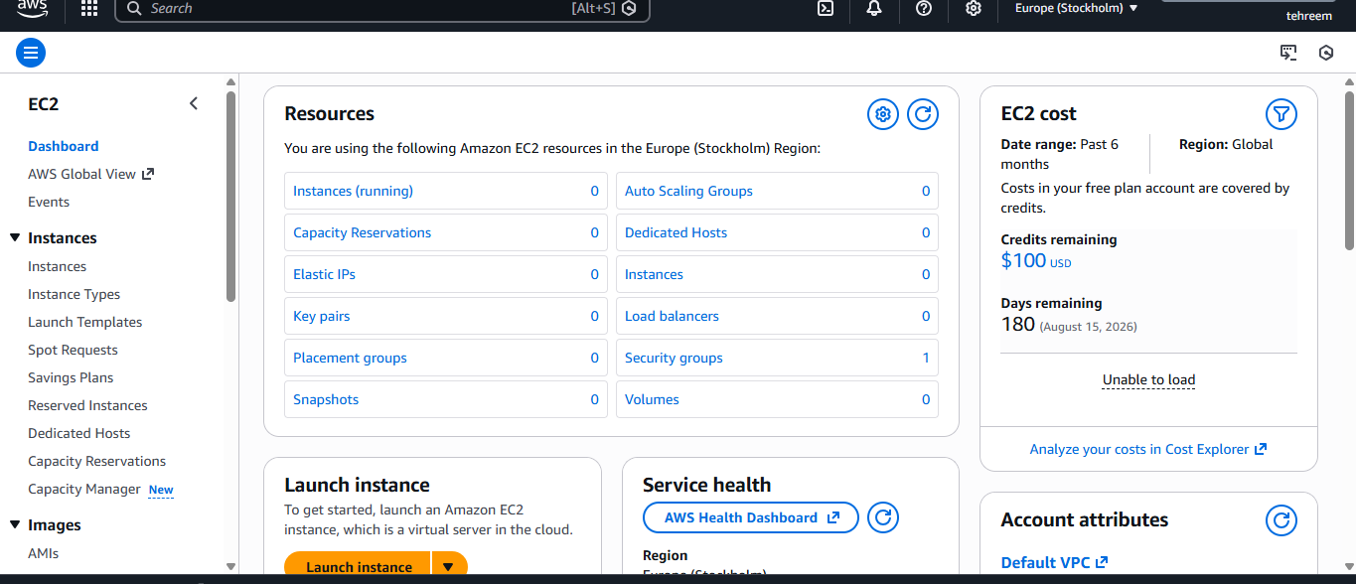

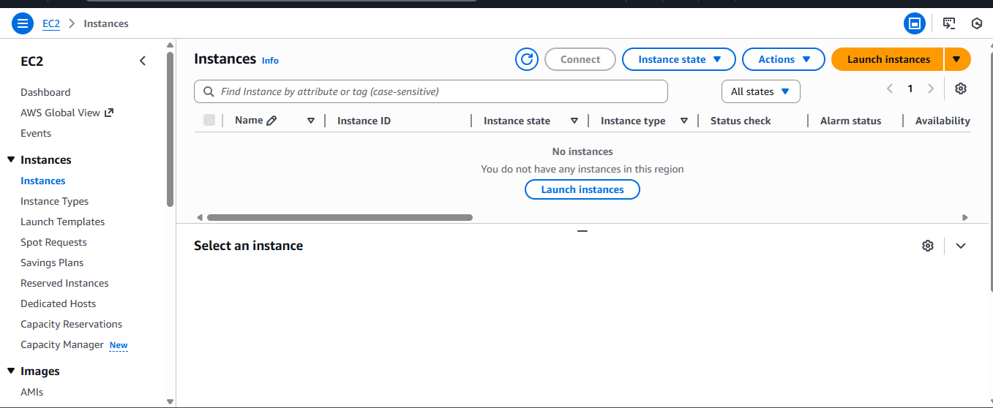

After clicking on launch instances:
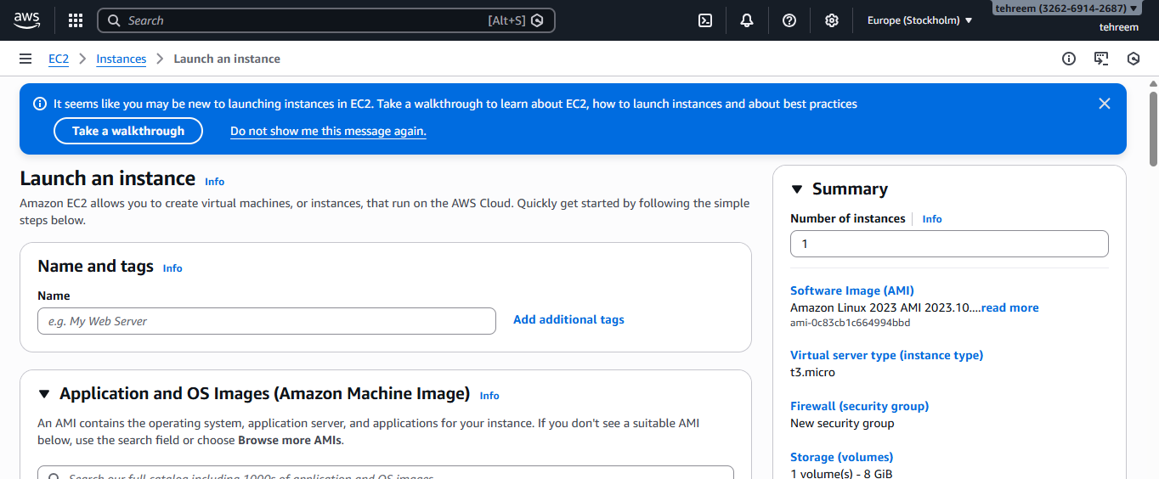

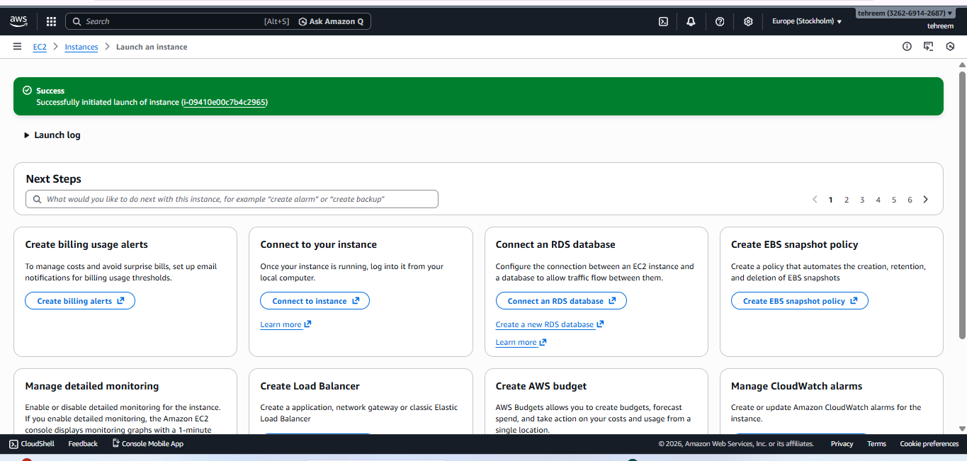

After clicking on view instances:
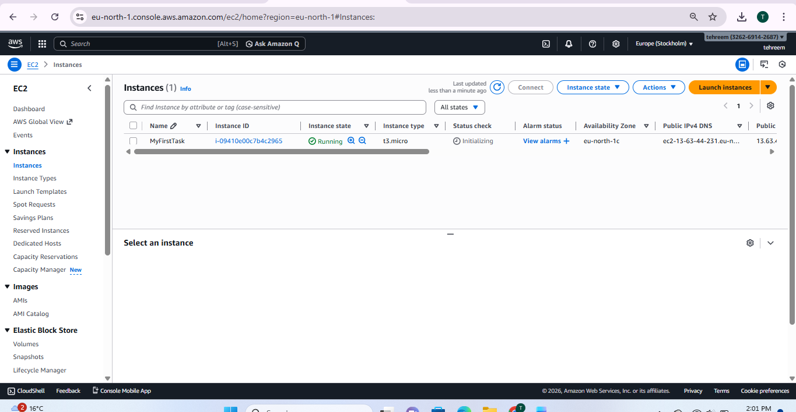

Now SSH to connect :
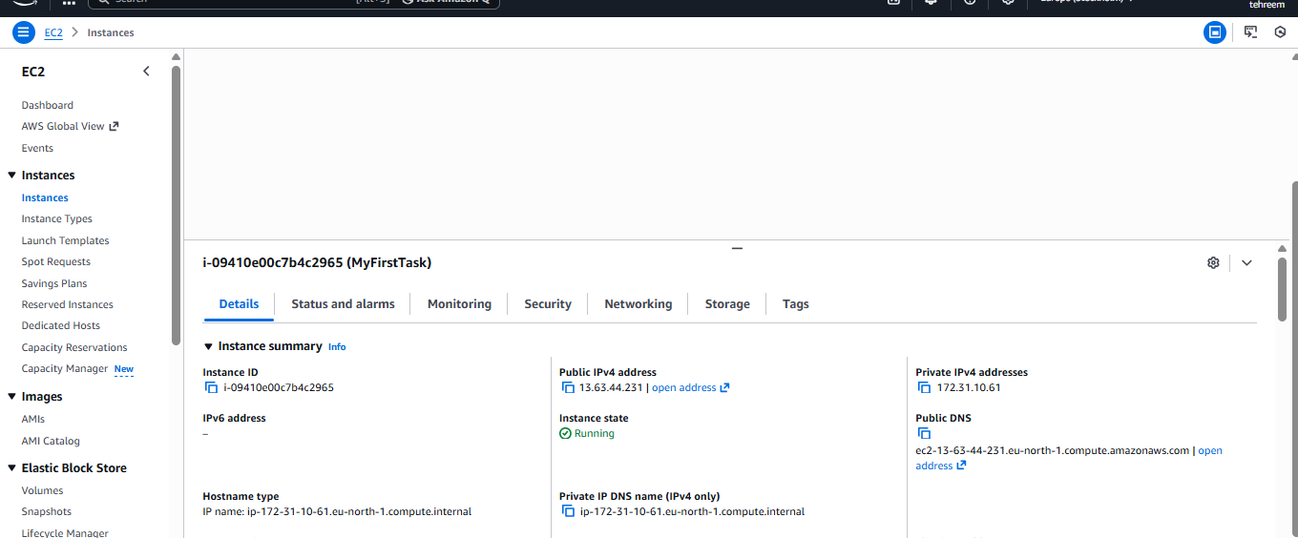

After pressing windows + R and write cmd and enter :



